A Monograph on the Coupling Coefficient, Mutual Inductance, and Quality Factor of a System of Coils

Christopher A. Tucker, School of Systems Engineering, University of Reading, UK

Abstract
This document will perform an analysis of Tesla’s system of four tuned circuits in context with a paper written by the author. And then some.

By the way: this is a bitch!
Contents
A. Introduction 1
B. The Coupling Coefficient 2
C. The Calculation of Mutual Inductance 4
D. Determination of the Quality Factor 5
E. Efficiency of the Scheme in Showing the Dependence upon a Qualified ‘Q’ 7
F. The Quality Factor subject to a Discussion of Wave Properties 8
G. Conclusions: Transportation of Mass in Energy Transmission 22

Introduction
Following “A Contribution to the Wireless Transmission of Power”, a discussion of the manner in which the system of equations describing the mid-range distant effects of secondary coils (name and name), specifically, the coupling coefficient 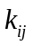 and mutual inductance 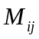 extant between these coils. The calculation of these variables, in context with properties of theoretical and physical coils, will be disclosed in the results section.

The author will attempt clarity in the task assessing only those the particular components necessary to the argument, including changing the naming of variables. To begin, the secondary coils described by Tesla in patent US546,654 are, in this monograph, denoted as 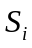 and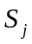.

Consider a system of four tuned circuits, first described by Tesla and shown in Fig.1, which facilitated the transmission of power without wires.

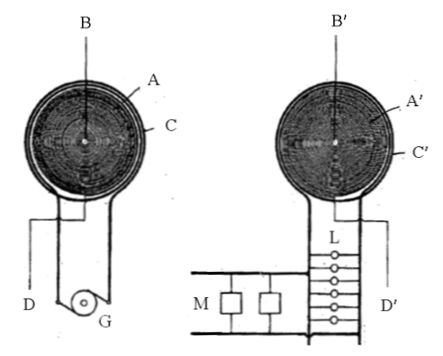
Fig.1: Tesla’s System of Four Tuned Circuits

The intention illustrated in the design is for a signal of significant energy potential to be input to the primary coil of one side of the circuit wherein it is simultaneously observed at the other side of the circuit. A schematic representation of the necessary variables is shown in Fig.2.

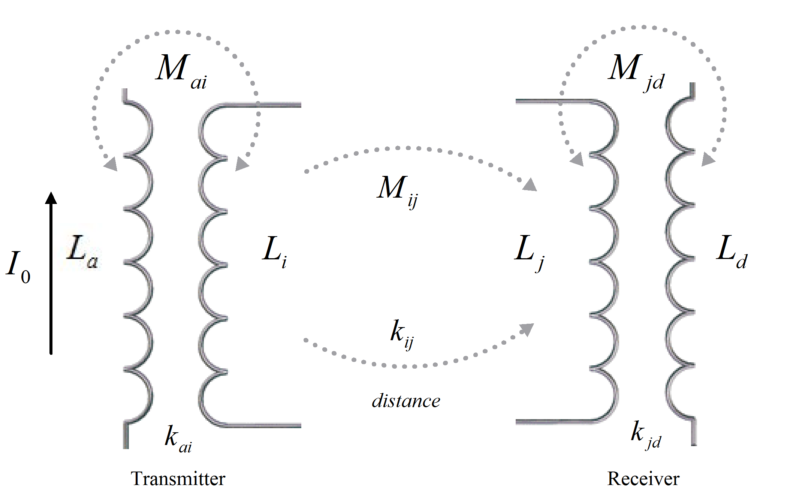
Fig.2: Schematic of System of Four Tuned Circuits

Words.

The Coupling Coefficient
In consideration of both the coil geometry and the total efficiency of the scheme, the quantities to be determined are: the coupling coefficient 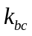, mutual inductance 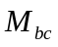 between distant coils 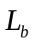 and 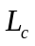, and the quality factors of all the coils. The mutual relationship and the coupling between each of the coils is illustrated in Fig.2.
[FUNKY DUCK: AN ITERATIVE CALCULATION OF THE COUPLING COEFFICIENTS!]
In light of the overall stress on the efficiency of the system [source]:
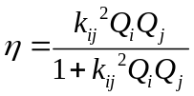,

it is interesting to calculate it in relation to the work done at a distance; i.e., the ability of the system to store energy, thereby transmitting it, determined by the coefficients in coupled-mode [1]. The coupled-mode, by inspection, is described by the following:

The flow of the energy across the distance is determined by calculating the coupling coefficient and mutual inductance of major and minor (arrangements). Referring to Fig.2, the major (arrangements) are 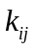 and between coils 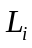 and 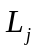 while the minor (arrangements) are 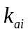 and 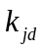, 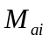 and 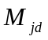 between coils 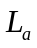 and , and coils and 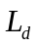 respectively.
[OLD DUCK: If the resonance frequency 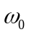 is kept constant, the inductances of coil and coil are small while the distances between coils and , coils and , and coils and are relatively large. Thus, 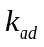, 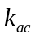, and 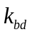 are relatively small and hence can be neglected.]
When current 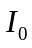 is applied to coil , the power transfer flows from coils to , to , and to .

The coupling coefficient between the major (arrangements--significant magnetically-coupled coils) is
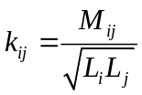,

while the coupling coefficient between the minor (arrangements--significant magnetically-coupled coils) is

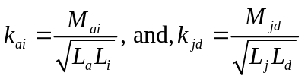.

Words. Reiterate 05728507.pdf paper to help refine the argument here. [FUNKIER DUCK: HOW ABOUT TRYING THIS AGAINST NUMBERS 6 AND 7?]
where 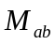, 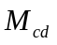, and are the mutual inductances, , and , and , are the self-inductances of the coils. Since we cannot calculate the coupling coefficient directly, we will need to calculate the inductances and the mutual inductance of the distant coils flowing with the current . For the coils and , we will use the approximation for the inductance of a circular loop [2]
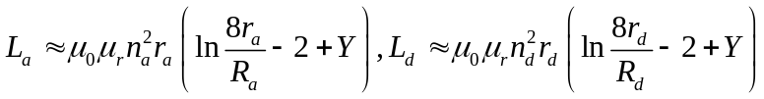

where , 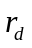 is the loop radius and 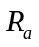, 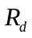 is the wire radius, 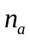, 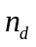 is the number of turns, and is the flow constant of the skin-effect of the emitted radiation. For the coils and , we will use the approximation for the inductance of an air-core flat spiral coil [3]
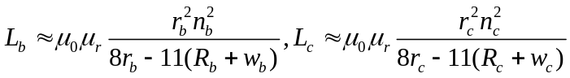
where , is the loop radius and 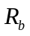, 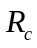 is the wire radius, 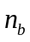, 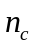 is the number of turns, and 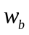, 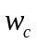 is the width between each turn of the windings. Table II shows the calculated values for the coils.

The Calculation of Mutual Inductance
Next, the mutual inductance is calculated using Stokes’ theorem [4].

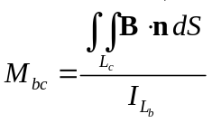

where is the area of the receiver secondary coil, B is the magnetic field, 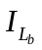is the current passing through the transmitter secondary coil and is the vector normal to the energy across free space. In examining mutual inductance and the distance, the space between is filled with a radiated field object resulting from the exchange of energy between the coils, whose size and shape is dependent upon coil geometry [5]. As such, we can expect the space to be a medium occupied by a charged field exhibiting an energy flow,( illustrated in Fig. 6).
Details of the field object are outside the scope of this paper. However, it does help aid in visualizing the propagation of magnetic currents in the distance between the coils and . An accurate calculation of mutual inductance depends on the distribution of the energy dispersed within this free space. It is assumed the magnetic currents to be evenly distributed not only from the Biot-Savart law, but also as the energy flow and shape representative of the geometry at the boundary. Under these assumptions, the calculated coupling coefficients and inductances are shown in Table I.
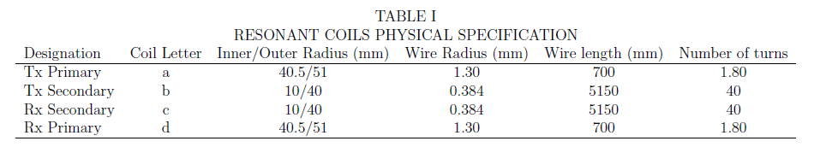
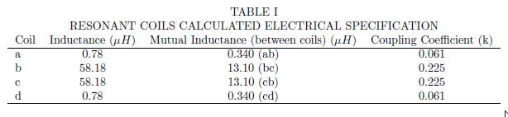
Words.

Determination of the Quality Factor
Words.

- What has inspired this: On page 3, with reference to equation (5), it is stated that when using two AC modes, quality values for the coils in terms of multiple receivers will be additive. This argument is potentially very important for multi sensor in body sites in terms of power transfer/provision. At this stage it needs some further explanation as to the theoretical basis for such a statement and the potential practical implications for wireless sensor systems. Allude to the monograph on k, M, and Q. This and the next are the most work.

- At the end of Section IV the multiple receiver issue is raised again with potential efficiencies of 82% - it would be good to have a little further information on this. For example what number of multiple receivers have actually been experimented on thus far? With exactly what results? Would you like sum more?

- FROM TEXT: As an interesting aside, it is also apparent that the same method of power delivery, as tested in our experimentation, can also be employed in the case of multiple receivers. With the addition of additional receivers, the transfer efficiency still remained at a minimum of 82%, whilst dividing the power – this being based on the position of the receivers relative to the transmitter. Clearly this can mean that the method introduced here could be useful to power several measurement and/or stimulating points within one body, without significant power degradation, from one single external transmission source.

- Tied for support with this: Several issues of IET Wireless Sensor Systems have now been published yet the authors do not reference any articles that have appeared. Yet several papers would appear to be directly relevant, particularly with regard to the power issues faced in this situation. The papers by Barker et. al. and Timmons et.al. appear to be directly relevant to this paper. The authors need to reflect this in their paper to indicate how such papers fit with their work and where there are differences – an extra paragraph or two with suitable references should suffice.

Output power of the scheme:

The argument in the work regarding the effectiveness of the scheme to deliver the equivalent quantity to a wired analogue is:

The concept of wireless power transfer, first described by Poynting [8, 9] and experimentally verified by Tesla [10, 11], has been illustrated in the literature as a viable method to transport electrical current between distant points [12, 13, 14, 15, 16]. The extension of this method herein maintains a significant amount of useful power transmitted at intensities of less than 15 volts in which, across a volume of air, magnetic waves are exchanged between two or more coupled resonators.

Consider a circuit consisting of a single loop of insulated wire wound in such a way as to create a circular loop of a few turns. This loop, connected in parallel to a capacitor, becomes one-half of a resonant circuit. This is designated as the transmitter . The length of the wire loop in is then replicated to construct a similar loop placed on an independent circuit board positioned a distance away and which is connected in parallel with a capacitor of the same reactive value and a load. In its entirety this becomes the second-half of a resonant circuit, designated the receiver .

Each half of the resonant circuit is placed a distance from the other. The transmitter is connected to a power source such that the LC circuit is excited. Because of the symmetry between each half of the circuit, magnetic waves flow from 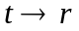 at resonance frequency 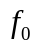 with an efficiency . When energized, this circuit engages an electrical field in the loop in , creating a magnetic field which is coupled to the loop in . By placing the load in parallel to the loop in , magnetic energy is converted into electrical current. The arrangement is illustrated in Figure 1.

A number of receivers can though be fed from one common transmitter, thereby opening up the potential to power mobile robotic platforms by this means. A theoretical configuration of the circuit in a robotic implementation is a single fixed-position transmitter delivering energy to distant receivers and . Such a circuit has been constructed and tested for the intensity of the induced current at different distances away from the transmitter. The receivers are grouped into two categories:

- AC mode: lighting an incandescent lamp, and,
- DC mode: turning a motor.

Either of the receiver or is a lamp or a motor; these become synonymous platforms in a mobile robot. The experimentally-tested range of this method is illustrated in Figure 2 and Figure 3.

Efficiency of the Scheme in Showing the Dependence upon a Qualified ‘Q’

The efficiency of the experimental model is calculated to be,
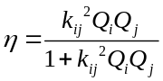
where is the coupling coefficient, 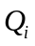, 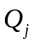 are the quality factor of the coils and driven at resonance frequency . Since the efficiency given the coil geometry is of interest, the coupling coefficient , mutual inductance between distant coils and , and the quality factors of all the coils must be determined.

Meanwhile, the coupling coefficient between magnetically-coupled coils in general is defined as
where is the mutual inductance, and the self-inductances of the coils.
Further to this the inductance of a circular loop [18] is:
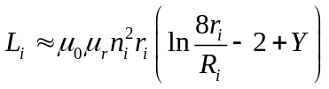, 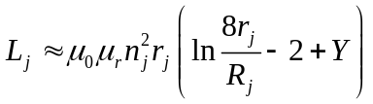
where , is the loop radius and 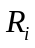, 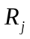 is the wire radius, 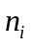, 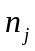 is the number of turns, and is the flow constant of the skin-effect of the emitted radiation.

To determine the mutual inductance apparent in this case, Stokes’ theorem [19] yields the value
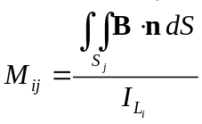
where 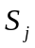 is the area of the receiver coil, B is the magnetic field, 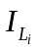is the current passing through the transmitter secondary coil and is the vector normal across free space. The loaded qualities, , as a property of the capacitance 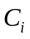, 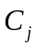, resistance , , and inductance , of the circuits containing the coils are defined:
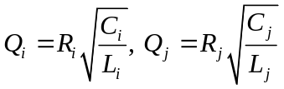

The Quality Factor subject to a Discussion of Wave Properties

UNDER QUESTION: When using two AC modes, quality values in respect of the second receiver are additive to the overall calculation. In this geometry, multiple receivers will exchange magnetic energy with the transmitter and each other. The resultant theoretically calculated values for the coils are shown in Table 1 and plotted in Figure 4, which shows both the theoretical and actual experimental results. This is for a parallel circuit. The Original Zierhofer p712, is similar to the series case except his Q is its reciprocal.

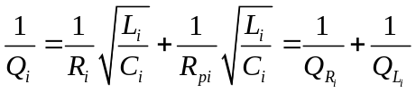

Revising Zeirhofer since the circuit is parallel resonant:
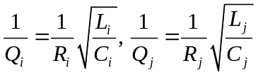
A circuit under parallel resonance, such as in the case of the oscillator under discussion, a R(G)LC parallel circuit consists of a resistor 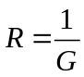, an inductor and a capacitor  connected in parallel to the input voltage:

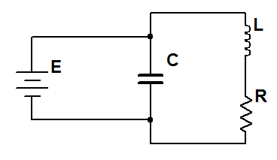

Generally speaking, the resistance is taken up as a property of the wire contained in the antenna, therefore the quantity R is low and contributes weakly to Q=omegaL/R, showing that without the amplifier package, the Q of the coils is near 40. However, in operation, the resistance tied to the time parameter in the MOSFET establishes the Q of the transmission element plus the effective resistance in the circuit, which would be the operational or real Q for the system. In either case, consider the conductance of the admittance 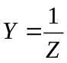 of each element. The overall admittance of three elements of Fig.xx is:

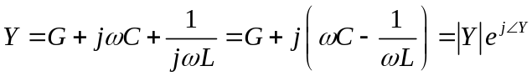

As:

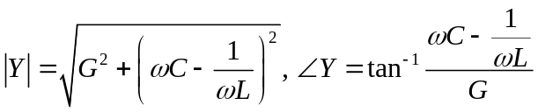

In particular when 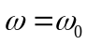 (at the resonant frequency)

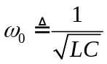
we have

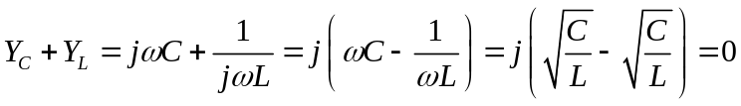

The effects of L and C cancel each other, and the complex admittance Y becomes real and its magnitude reaches its minimum when

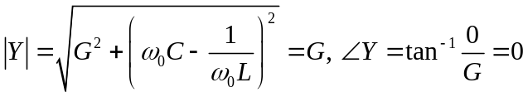
And the current reaches a minimum value 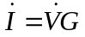. In particular, if the resistor does not exist (as in the case of the transmitter—only relying on the small resistance present in the wire and across the capacitor—i.e., 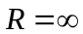 and 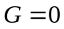, then the admittance 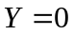 and 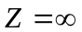. However, even for small resistances, it is shown that admittance can only approach zero for small time t.

The quality factor of a parallel resonant circuit 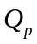 is defined as the ratio of the magnitude of the inductor/capacitor susceptance and the conductance:

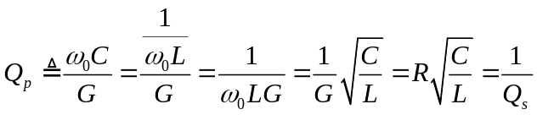

Note that for a parallel RLC circuit is the reciprocal of 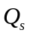 for a series RLC circuit. The currents through each of the three components are:

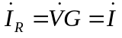

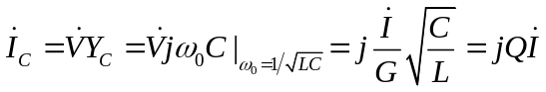

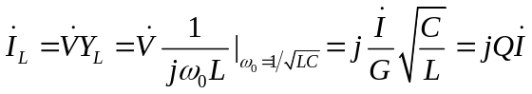

The magnitude of the current 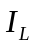 through L and 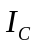 through C and Q times larger than the current 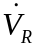 through R which is the same as the current source . But as and are in opposite direction they form a loop of current through L and C with no effect to the rest of the circuit. The genius of the circuit is that the parallel RLC circuit behaves like a bandstop filter which can be intuitively understood. When is high, the capacitor’s impedance 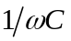 is low, and when is low, the inductor’s impedance 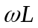 is low. When the overall impedance is the largest. However, if the input is a current source, the voltage across the elements 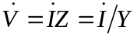 will reach a maximum value when .

More directly is relevant to describing the state of the oscillator at a particular time t when:

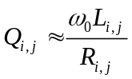

For the purposes here, is quality factor due to 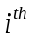loop element, quality factor due to the 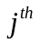 loop element. Following Zeirhofer [20:712] and his description of the determination of efficiency 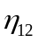, for the ratio between the power delivered to the receiver circuit and the overall power consumption is given by when using multiple receivers:

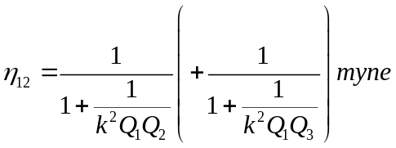

Where k is the coupling coefficient . For this equation it is assumed that the system is operated at the center frequency, i.e., .

- Therefore the efficiency improved by the addition of more Q’s, and not additive Q’s in the sense of Eq.12.

Can it be shown that (11) and (12); and (13) and (7) are equivalent to satisfy the additive question?

- Additive Q meaning that the more receivers placed, the greater the push of Q to a critically damped state. Q dependent upon proximity of receivers to the transmitter but to a peak value equal to the maximum power state of the amplifier package.

Firstly: equation 5 from the original paper is wrong; rather, the following shows the greatest equivalency between two separate equations,

[NOTES how Q is determined and what it symbolizes. Q = 0.397, 2Q = 0.794, ζ = 1/2Q = 1.259. ]

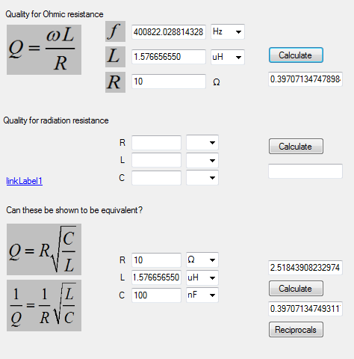
Fig.1. Best Q (verified by CircuitCalculator program).

SOLUTION: Answer for the purposes of the monograph, but glance over it for the paper.

Comment: additive quality is a proper description satisfies unloaded case; when power is available from the oscillator to satisfy the power consumed in the loaded case, is the limit of the number of receivers to a single oscillator. Subtle change to the equation 5, move additive expression to that of efficiency to the limit of the oscillator’s power.

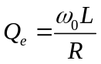

NOTE: Double transmitter constructed and tested for operation. Heavy magnetic field generated which disturbed the state of the drive on this laptop. Answers some of the questions about quality in multiple coils.

The determination of the effective quality factor 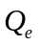 and the effective damping factor 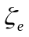 are based on the states of Q and ζ for each instance of the antenna elements, represented as 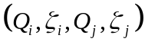 for each and elements. The states are interesting as they describe the behavior of the system when there are small changes in R, given Eq.25 and shown in Table 1.

Table 1. Oscillation properties.
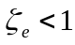 | 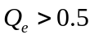 | underdamped
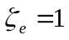 | 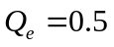 | critically damped
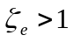 | 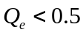 | overdamped

Depending on the values of the effective damping and the effective quality factor in both the antenna and the oscillator, considered as a whole inter-dependent system, the emitted waveform will be one of three types, termed hereafter as oscillator “states”:

- Underdamped,
- Critically damped,
- Overdamped.

The meaning represented in the different states of oscillation is due to the displacement of a wave in space given its periodic motion. In order to satisfy periodicity, the oscillator must be elastic—in the sense of returning precisely to its original configuration after deformation: this requires a known position of equilibrium and a counter force which restores equilibrium. The oscillator must be able to produce a sustained single frequency on a source object with a tolerance small enough that an object designed to absorb the oscillations will do so if it has approximately the same parameters. The antenna will consist the vibrator while the oscillator will provide synchronous amplitude over  radians, or a full duty cycle. A general description is illustrated in Fig.2.

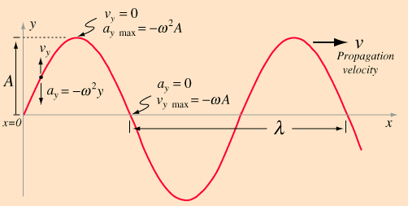
Fig.2. Traveling wave description.

Electric periodic motion is analogous mathematically to a mass on a spring of a single frequency in simple harmonic motion. In the present case under discussion, a traveling wave is emitted from the oscillator. A description of such a periodic motion contains the following parameters as attributes:

- Period,
- Frequency,
- Amplitude,
- Velocity (of propagation),
- Wavelength.

In the traveling wave case, since we are dealing with radiative phenomenon, as opposed to Tesla’s standing wave scheme. We will need to discuss what consists the traveling wave phenomenon. The single frequency traveling wave takes the form of a sine wave. The traveling wave solution to the wave equation will be written showing the choice of parameters to describe it, inclusive of the periodic motion parameters amplitude, period, and frequency. This solution to the traveling wave is first given by the wave equation in one-dimension [SOURCE]:

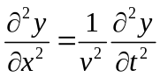

and in two dimensions of the form:

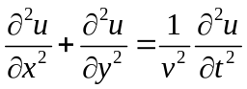

where is the phase velocity. Given that the wave propagates in a 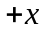 direction, the description of the transverse motion 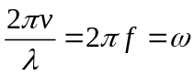, where 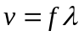shows

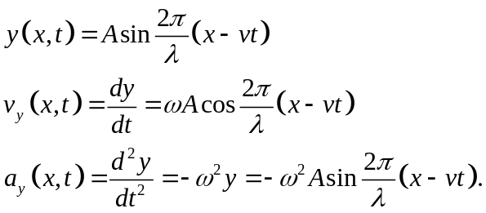

The equivalent forms of the wave solution are given by

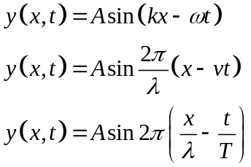

Containing the wave parameters shown in Table 2.

Table 2. Basic wave parameters.
Amplitude  | Wavelength
Period 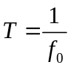 | Wave number 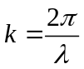
Frequency 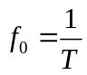 | Angular frequency 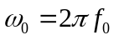
Propagation speed | Wave relationship 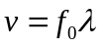

The velocity is determined by the properties of the medium, in this case atmospheric air and independent of other parameters, but can be determined approximately by using the wave relationship equation in Table 2.

A solution presented here will be, present the assumptions of the wave character displayed in the prototype, will be for a traveling wave solution for an

[DUCK: NEED WORK DISCOVERING THE TRAVELING WAVE SOLUTION DESIRABLE FOR THIS WORK.]

Rounding out back to the limit where the discussion of plane waves becomes too general to be useful to describe the specific case of this oscillator

Because, in the wireless power case, the traveling wave emitted by the antenna as a function of the amplitude generated in the oscillator, is confined to one plane in space and varies sinusoidally in both space and time is expressed in combinations of:

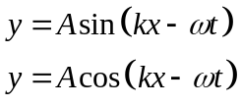
and of the complex form,

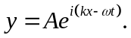

Taken as a Euler identity the form takes

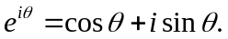

There will be only a light discussion on the quantum-mechanical nature of these waves, only where it is relevant in terms of quantum electrodynamics [FEYNMAN].

Given the above theoretical and mathematical discussion, to reach a point where to describe the driven state of the oscillator under study: the system is overdamped at values of 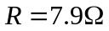; at the effective resistance of the circuit, is much lower than this, typically 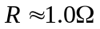. Therefore, under typical operating conditions, the circuit is underdamped. The motion looks like:

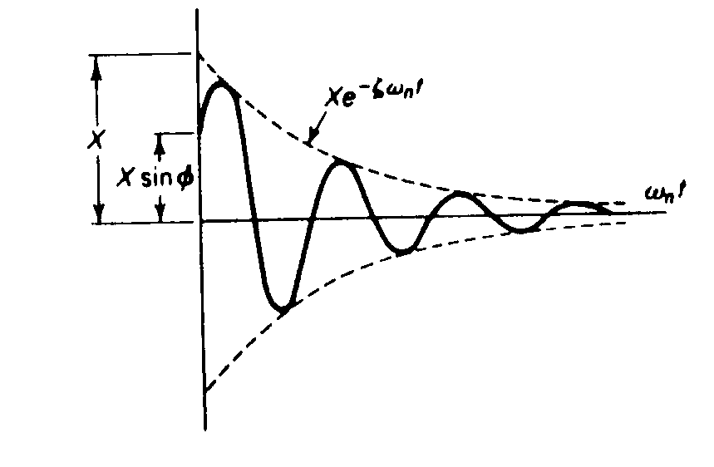

Which is not unlike the data from the simulated scope trace. [CHECK THE DIRECTION OF FLOW ON THE OSCILLOSCOPE AND SET THE MOTION EQUATIONS AS SUCH.]

The underdamped response of the oscillator is described by the equation

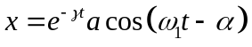
Shown in Fig.3. For any value of the damping coefficient

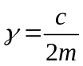

where a damped oscillator is subject to a damping force which is linearly dependent upon the velocity, the oscillation will have exponential decay terms which depend upon a damping coefficient. If the damping force is of the form

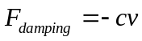
it is proportional to , taken as a constant.

If the critical damping factor 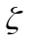 is greater than this, the mass will overshoot the zero point and oscillate about . In the case here, the damped oscillator is underdamped. It approaches zero faster than in the case of critical damping, but oscillates around zero.

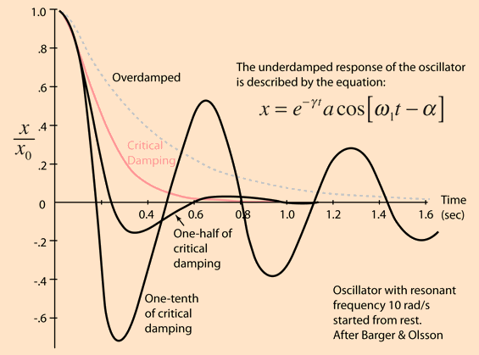
Fig.3. Underdamped oscillation.
The behavior is shown for one-half and one-tenth of the critical damping factor. Also shown is an example of the overdamped case with twice the critical damping factor .

So is it at some point in t the system, once the amplifiers are not driving the system, decays as an underdamped system.

NEXT.

The Driven Case

The system architecturally, is a case of simple harmonic motion of a rotational mass 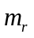 in the presence of a counter-force analogous to a spring with stiffness . As it is an energy system and not necessarily an object-based system, the equations will be adapted from the traditional object-mass and spring models determining Work-Energy principles performed in the system.

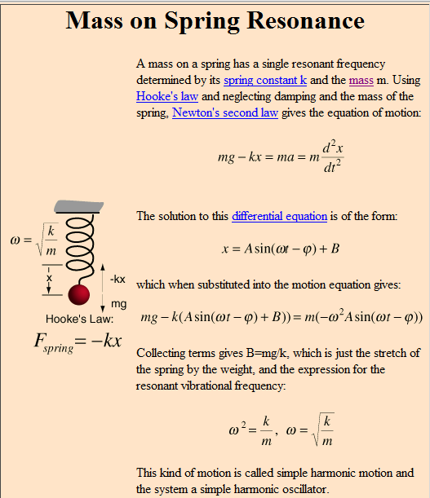transpose ME

The simple harmonic motion of a mass on a spring is an example of an energy transformation between potential energy

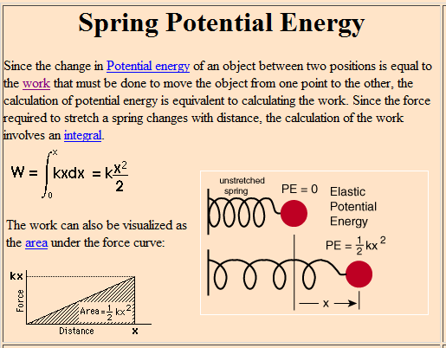

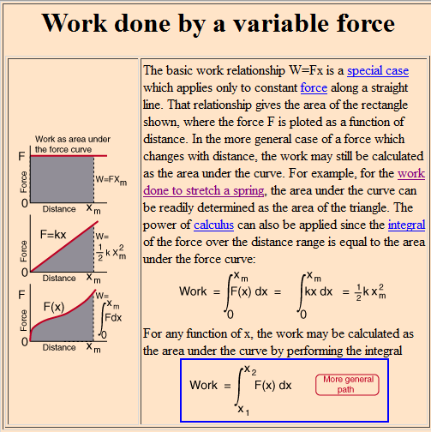

and kinetic energy.

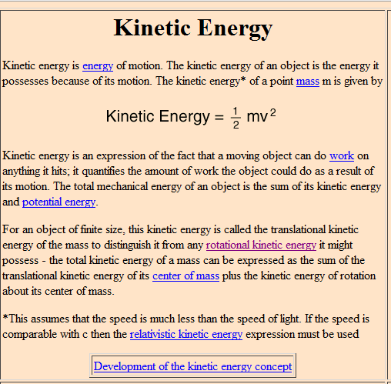
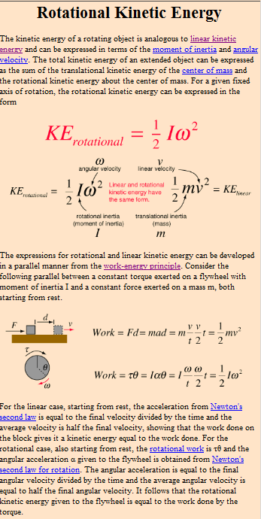

In the example below, it is assumed that 2 joules of work has been done to set the mass in motion.

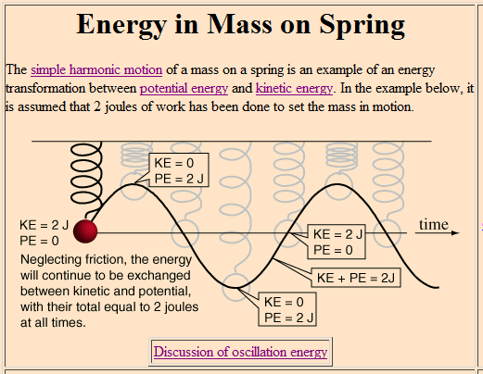

Since dealing with acceleration of electrons and the emission of (electromagnetic) photons in the case of the magnetic loop antenna arrangement, masses can be considered as related to the mass of the accelerated electrons and elastic forces of those electrons, the work performed to raise their energetic state and the release of the energy in the form of photons. Finally, we can collect the equations for an underdamped driven oscillator, the case described in this thesis.

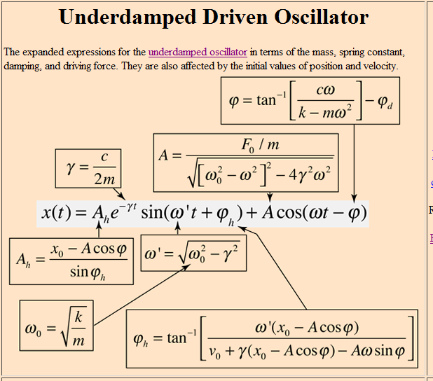

Solution to the notion of “additive” quality factors

Using three receivers, Q will be additive for each receiver from the perspective of the entire efficiency calculation of equation (1); modified given [32]:

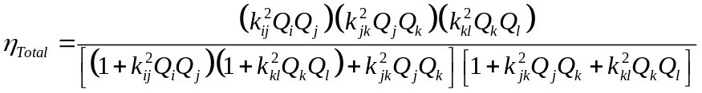

If it is desirable to consider the interaction of the magnetic fields each of the elements: transmitter, receiver one, receiver two, etc operating on each other. If the consideration is given that the operation is limited to between a transmitter and receiver one, receiver two exclusively (i.e., not interested in the coupling between each receiver but noticing the improvement in k as in Eq.1) then the total is given [20] by:

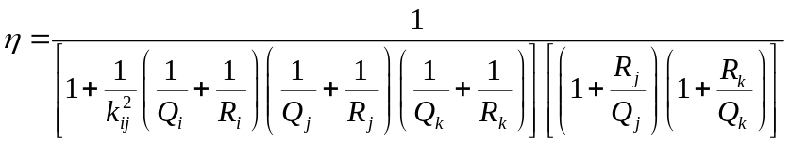

[DUCK: is it this lack of mass, to do real work, of the reason can’t turn a motor while a nearly dead 1.5V AA cell will? In the battery case, dealing with real electrons; in the wireless case, dealing with photons.]

Limit the discussion of this at the quantum level, suggesting a study of QED, Feynman.

Conclusions: Transportation of Mass in Energy Transmission

Electromagnetic photons have no mass therefore cannot perform real work, such as providing enough torque to increase the rotation force of the wave, which is done typically by electrons, which have mass. It has been shown that torque can be generated to turn a DC motor, via power conversion. Therefore, either the photon stream is not entirely massless or something can be done while manipulating the photons to transfer the energy back to electrons.

References
- H.A. Haus and W. Huang. “Coupled-Mode Theory,” Proceedings of the IEEE, vol. 79, no. 10, Oct. 1991.
- R. S. Elliott, Electromagnetics. New York, IEEE Press, 1993.
- H. A. Wheeler, “Simple Inductance Formulas for Radio Coils,” Proceedings of the Institute of Radio Engineers, vol. 16, issue 10, pp. 1398-1400, 1928.
- L. Hannakam, “Berechnung der Gegeninduktivitat achsenparalleler Zylinderspulen,” Archivfiir Elektrotechnik, vol. 51, no. 3, pp. 141-154, 1967.
- J.H. Poynting, “On the Connection Between Electric Current and the Electric and Magnetic Inductions in the Surrounding Field”, Philosophical Transactions of the Royal Society, 176, pp. 277-306, 1885.

A. RamRakhyani, S. Mirabbasi, and M. Chiao. “Design and Optimization of Resonance-Based Efficient Wireless Power Delivery Systems for Biomedical Implants”, IEEE Transactions on Biomedical Circuits and Systems, Vol. 5, No. 1, Feb. 2011.
E. S. Hochmair, “System optimization for improved accuracy in transcutaneous signal and power transmission,” IEEE Transactions on Biomedical Engineering, Vol. 31, pp. 177-186, Feb. 1984.
C.M. Zierhofer, “Geometric Approach for Coupling Enhancement of Magnetically Coupled Coils,” IEEE Transactions on Biomedical Engineering, Vol. 43, No. 7, Jul. 1996.

